Deprecated Functions
Perform Scan Procedure

Revision
Version 2
4/13/26 10:45 AM

SME
Charles Wilson

Abstract
This document describes the procedure used to perform the perform scan activity described in the AVCDL ^{[1]} secondary document Currently Used Deprecated Functions Document ^{[2]}.

Group / Owner
Security / Security Architect

Motivation
This document is motivated by the need to document and justify the use of deprecated functions in the development of software for use within safety-critical, cyber-physical systems.
Note: Within the context of this document, the terms security and cybersecurity are used interchangeably. It is presumed that the term security is being used in reference to cybersecurity and not physical security.

License
This work was created by Torc Robotics and is licensed under the Creative Commons Attribution-Share Alike (CC BY-SA-4.0) License.
https://creativecommons.org/licenses/by/4.0/legalcode

Audience
The audience of this document is the cybersecurity practitioner who will be responsible for the deprecated function scanning.

Completeness of Output
Since the incorporation of scanning for deprecated functions is an as-is analysis, it is critical to ensure that the information gathered is as accurate and complete as possible. All information should be sourced from and confirmed by the owner of the element under consideration.

Disposition of Output
This activity does not produce documentation as an output.

Entry Criteria
This document assumes that the reader understands the purpose of cybersecurity-specific static analysis. Further, that the reader has read and understood the AVCDL Currently Used Deprecated Functions Document secondary document.

Prerequisites – Input Materials
It is required that the build file has been updated as a result of the deprecated functions incorporate scan activity. It is further required that the scanning tool have the access to the element source code necessary to complete the procedure.

Perform Scan Activity
The workflow diagram for the perform scan activity of the Deprecated Functions process is shown below.
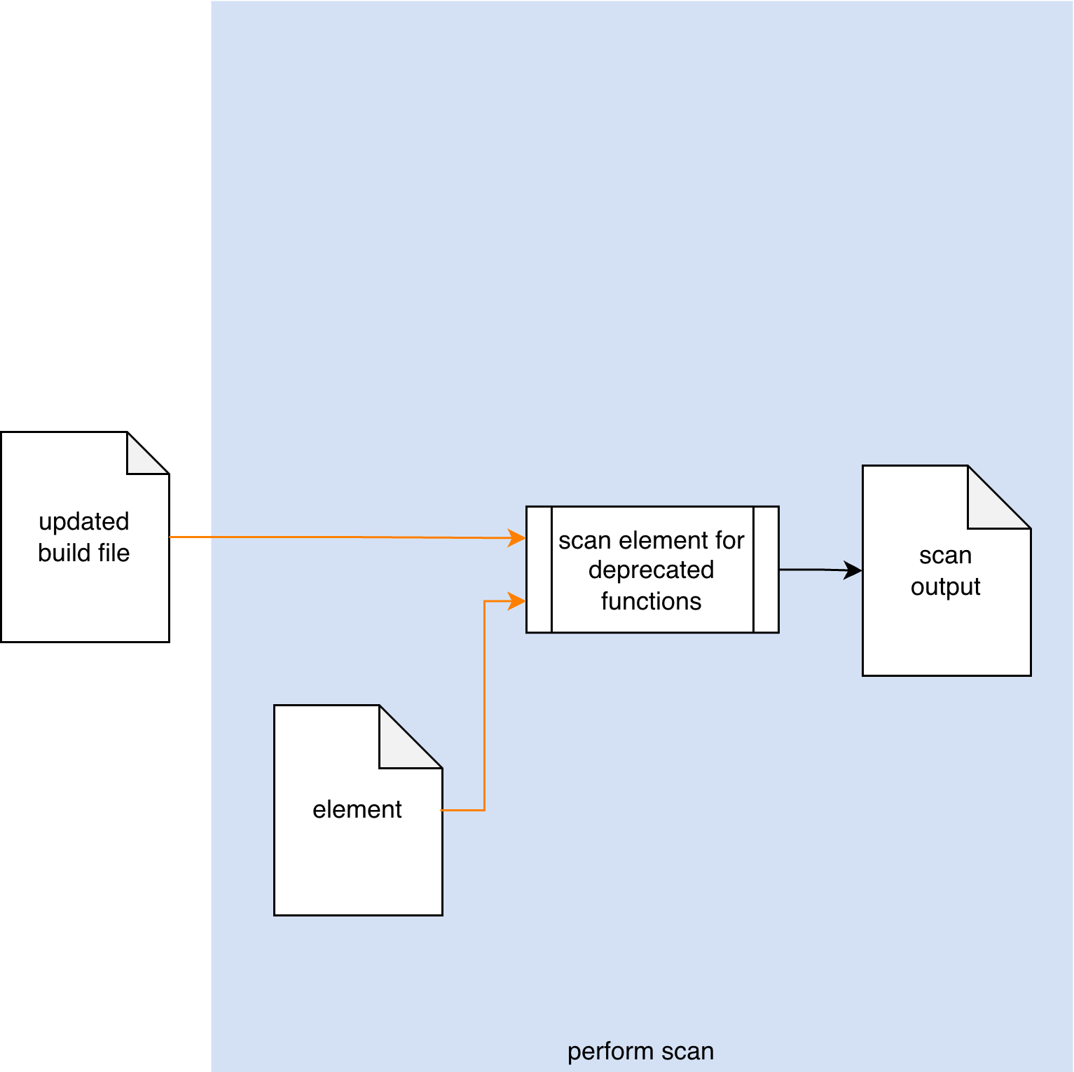
The Updated Build File invokes the tool used to take the Element under consideration and scan for deprecated functions. A Scan Output list is generated.
Note: This activity may be performed manually.
Note: It is recommended that the scan output be a SARIF ^{[4]} encoded JSON file.

Methodology
If the preceding activity of incorporating the scanning tool into the build has been properly followed, this activity should just work. Its inclusion should therefore be simply to provide completeness to the deprecated functions process. Any issues which arise should fall into one of the categories covered in the next section.

Considerations
The following item was introduced in the Considerations section of the Deprecated Functions – Incorporate Scan Procedure ^{[3]} document. We come back to it because although they should have been addressed during the pre-flight of the test within the CI/CD system, these may still need to be addressed within the context of the live CI/CD process.

Execution Impact
Although deprecated function scanning is not an inherently resource intensive activity, it is still important to ensure that sufficient resources (time, memory, storage) are available.
Over time, the scope of the analysis activity will likely consume more resources. Be sure to monitor the time required for the activity to complete.

Exit Criteria
This procedure is considered complete once the Scan Output has been generated.

References
- AVCDL (AVCDL primary document)
- Currently Used Deprecated Functions Document (AVCDL secondary document)
- Deprecated Functions – Incorporate Scan Procedure (AVCDL tertiary document)
- Static Analysis Results Interchange Format (SARIF) Version 2.1.0
https://docs.oasis-open.org/sarif/sarif/v2.1.0/os/sarif-v2.1.0-os.pdf

